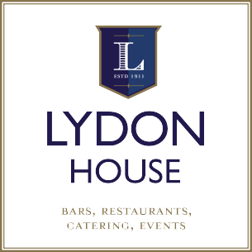 |  | Office Use only:
 |  | Position Appointed: |  | Department: |  | Employee No:
 |  | Rate of Pay: |  | PPS Number: |  | Visa Type:
 |  | U18 age verified by: |  | Visa verified by: |  | Hours permitted:

Contact Information
FIRST NAME: |  |  | SURNAME: |  | EMAIL ADDRESS:

ADDRESS:
EIR CODE:

MOBILE NO: |  | PPS:1*

DATE OF  BIRTH:2* |  | POSITION APPLIED FOR:

Criminal Convictions: | YES |  | NO |  | If yes, please provide details below:

Eligible to work in Ireland | YES |  | NO |  | Please provide visa stipulation re hours below

Emergency Contact Name:  (must be based in Ireland) |  | Emergency Contact No:

Work Experience History: (relevant to role you are applying for where possible)
Company & Location |  | Dates To – From |  | Company & Location |  | Dates To-From
Position: |  |  |  | Position:
Duties: (please provide details of the tasks undertaken) |  |  |  | Duties: (please provide details of the tasks undertaken)
Referee Name |  | Contact No. |  | Referee Name |  | Contact No.

Do you have a medical condition that may inhibit you carrying out your duties? | Yes |  |  | No
If yes, please provide details of supports (if any) that may assist you:

Have you worked with Lydon House previously? | Yes |  |  | No
If yes, please provide details:

DECLARATION: The above information is true and if employed, I agree to abide by the company regulations and Employee Handbook rules. I consent to my data being processed for the purpose of my recruitment by Lydon House and I understand it will be stored securely and not shared with any third parties other than Revenue or relevant regulatory bodies .I reserve the right to withdraw my consent at any time by contacting hr@lydonhouse.com. I agree to receive text and email alerts from Lydon House regarding upcoming events. .Note: All unsuccessful applications will be deleted/securely destroyed after racing season.

Signature:  (Type if applying electronically) |  | Date:
1* A valid PPS number is required prior to an offer of employment being confirmed but can be withheld at application stage if preferred.
2* Applicants under 18 years must produce either their passport or original birth certificate at interview stage.
Catering & Waiting Staff Applications to: recruitment@lydonhouse.com
Chef Applications: mike@lydonhousecatering.com
Bar Applications to: barstaff@lydonhouse.com
00353(0)91 564156
Human Resources, Lydon House, 3 Buttermilk Walk, Middle St. Galway

